**Allure Reporting with Selenium TestNg**

**Step-1:** Modify Maven pom.xml

For Allure integration, you need to add below maven dependencies into your **pom.xml file**.

### ****Properties Section****

### **<properties>**

### **<jre.level>1.8</jre.level>**

### **<jdk.level>1.8</jdk.level>**

### **<aspectj.version>1.9.2</aspectj.version>**

### **</properties>**

### ****Allure TestNG Dependency****

### **<!-- https://mvnrepository.com/artifact/io.qameta.allure/allure-testng -->**

### **<dependency>**

### **<groupId>io.qameta.allure</groupId>**

### **<artifactId>allure-testng</artifactId>**

### **<version>2.10.0</version>**

### **</dependency>**

### ****Build Section****

<build>

<plugins>

<!-- Compiler plug-in -->

<plugin>

<groupId>org.apache.maven.plugins</groupId>

<artifactId>maven-compiler-plugin</artifactId>

<version>3.5.1</version>

<configuration>

<source>${jdk.level}</source>

<target>${jdk.level}</target>

</configuration>

</plugin>

<!-- Added Surefire Plugin configuration to execute tests -->

<plugin>

<groupId>org.apache.maven.plugins</groupId>

<artifactId>maven-surefire-plugin</artifactId>

<version>2.19.1</version>

<configuration>

<testFailureIgnore>true</testFailureIgnore>

<argLine>

-javaagent:"${settings.localRepository}/org/aspectj/aspectjweaver/${aspectj.version}/aspectjweaver-${aspectj.version}.jar"

</argLine>

<suiteXmlFiles>

<suiteXmlFile>testng.xml</suiteXmlFile>

</suiteXmlFiles>

</configuration>

<dependencies>

<dependency>

<groupId>org.aspectj</groupId>

<artifactId>aspectjweaver</artifactId>

<version>${aspectj.version}</version>

</dependency>

</dependencies>

</plugin>

</plugins>

</build>

<reporting>

<excludeDefaults>true</excludeDefaults>

<plugins>

<plugin>

<groupId>io.qameta.allure</groupId>

<artifactId>allure-maven</artifactId>

<version>2.10.0</version>

</plugin>

</plugins>

</reporting>

and we are done! The pom.xml settings have been finished.

**Step 2:** Install Allure Binary file from this link - <https://github.com/allure-framework/allure2/releases> into local machine and unzip it to particular location. In this blog I am using version 2.8.0.

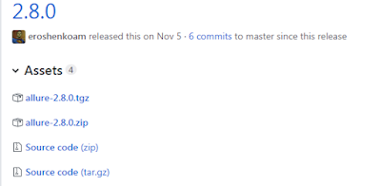

**Step 3:** Go to windows Control Panel and Set environment variable & provide the path of this binary file till bin folder.

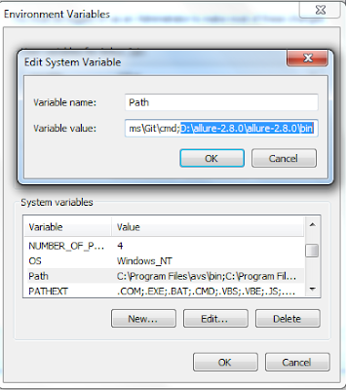

**Step 4:**  For Validation type allure --version in command prompt to make sure that allure binary file is setup correctly.

https://2.bp.blogspot.com/-FEvehKMHAXk/XBnwU-fDrII/AAAAAAAAqD0/igQNxbb0U98atH3vxQxIhLGJGBJRpoLQACLcBGAs/s400/allure-version.PNG

**Step 5:**  Now execute our TestNg project.

**Step 6:**  Refresh Our project now we will see one new folder named as allure-results will be generated which will contain one result and json file corresponding to each test case.

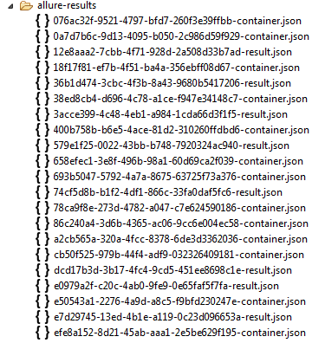

**Step 7:** Now Again go to Command Prompt and type below command

allure server Path of allure result

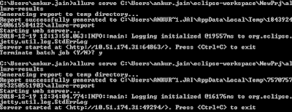

**Step 8:** Result of this execution would be:

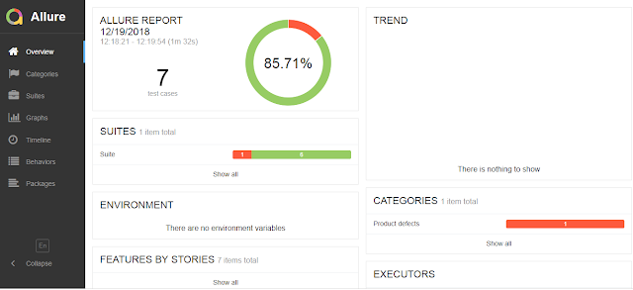

**Step 9:** Need to install following Allure plugin:

1. Go to Manage Jenkins -> Manage Plugins -> “Available” tab.
2. Filter for “Allure” and install it without restart.

**Step 10:** AddingAllure Command Line tool:

1. Go to Manage Jenkins -> Global Tool Configuration -> find Allure CommandLine installations…

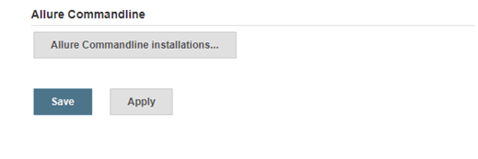

1. Click on the “Allure CommandLine Installations…”, specify any preferred name and then click on the “Install automatically”.

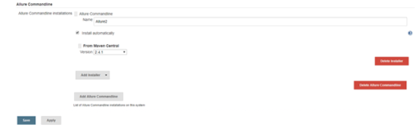

1. From Maven Central, version 3.6.0 is selected, so we click “Save”